Food Chains and Food Webs
Multiple Choice
- State what is shown on a food chain.
- How closely related organisms are.
- Where organisms live on Earth.
- Who eats whom in an ecosystem.
- The adaptations organisms have.

- Recall what a food chain shows the flow of.
- Animals
- Water
- Oxygen
- Energy

- State what type of organism is always found at the bottom of a food chain.
- Producer
- Predator
- Decomposer
- Consumer

- State what we call the organism at the very top of a food chain.
- Ceiling species
- Herbivore
- Primary producer
- Apex predator

- State what is shown on a food web.
- The overall flow of energy through an ecosystem.
- Places inhabited by venomous spider species.
- The flow of energy between organisms in an ecosystem.
- The geographic area covered by an ecosystem.

The following 3 questions use the following picture.
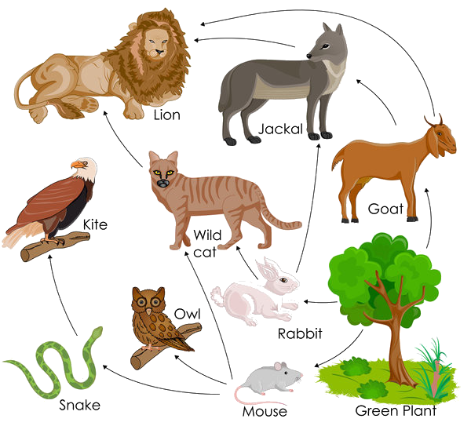
- In this food web, identify what the wild cat eats.
(Select all that apply)
Select ALL correct options
- Snake
- Goat
- Owl
- Mouse
- Rabbit
- Green plant

- In this food web, identify what the jackal eats.
(Select all that apply)
Select ALL correct options
- Snake
- Goat
- Owl
- Mouse
- Rabbit
- Green plant

- In this food web, identify what the rabbit eats.
(Select all that apply)
Select ALL correct options
- Snake
- Goat
- Owl
- Mouse
- Rabbit
- Green plant

The following 3 questions use the following picture.
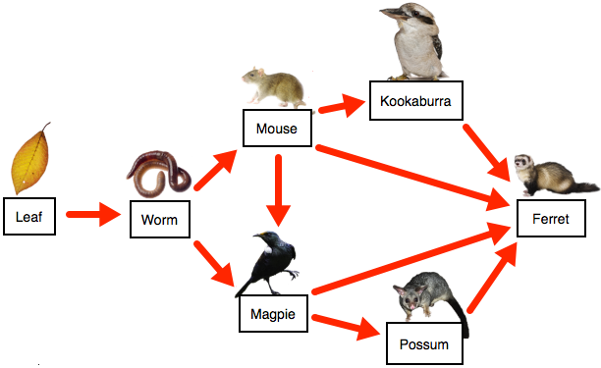
- In the food web below, identify what is eaten by the magpie.
(There may be more than one correct answer!)
Select ALL correct options
- Ferret
- Kookaburra
- Mouse
- Worm
- Leaf
- Possum

- In the food web below, identify what is eaten by the ferret.
(There may be more than one correct answer!)
Select ALL correct options
- Possum
- Leaf
- Magpie
- Mouse
- Worm
- Kookaburra

- In the food web below, identify what is eaten by the worm.
- Possum
- Leaf
- Magpie
- Mouse
- Worm
- Kookaburra
Fill in the blanks
- Use the following words to fill in the gaps.
Rabbit, Fox, Grass

_______________ __________________ ___________________

- Use the following words to fill in the gaps.
Shark, Seaweed, Fish

_______________ __________________ ___________________

- Use the following words to fill in the gaps.
Deer, Grass, Wolf

_______________ __________________ ___________________

- Use the following words to fill in the gaps.
Hawks, Grass, Mouse

_______________ __________________ ___________________

- Use the following words to fill in the gaps.
Frog, Caterpillar, Flower

_______________ __________________ ___________________

Short Answer
- Distinguish between a food chain and a food web.

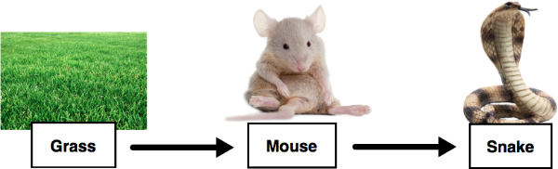

Discuss what is represented by the order of a food chain. Use the food chain above as an example and consider:
- The types of organisms;
- Their interactions with each other;
- What the arrows mean.

